MAG LEVEL 2 FLOOR (1)
Statics | 1. ® © Candle stand | 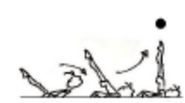
  - From squat position, roll backward to shoulder stand-keeping arms flat to the floor (hold 2 secs).
 | 2. ® © 180’ roll Sideways | 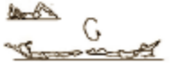
  - Lower to backward lying position with arms extended. Roll 180º sideways to forward lying position, arms still extended.
 | 3. ® © Front Support | 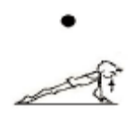
  - Circle arms sideways to bent position by chest and push to front support (hold 2 secs).
 | 4. ® © Kneel Stand | 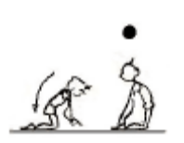
  - Place knees on the floor. Grasp heels and press hips forward (hold 2 secs).
Fwd Roll | 1. ®© Fwd roll to stretch jump | 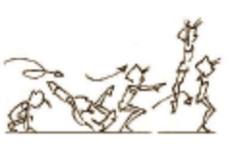
  - Tucked forward roll and vertical stretch jump to stand.
Handstand (for walkover, handspring and flic flac) | 1. Angry Cat Drill Revision – hold 30 secs
 | 2. Lying on stomach with hands against a wall – looking at hands, covering ears – chest in, bottom squeezed – hold 30 secs
 | 3. Handstand with nose against wall – looking at hands – covering ears, hips open, bottom squeezed. Push “tall” up the wall – hold 30 secs
 | 4. F2-1.5 Handstand against a wall, with the back to the wall and with the stomach against the wall – when the gymnast can balance well – have them pull their feet slightly away from the wall | 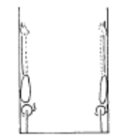 | - arms straight  - chest rounded, extended through the shoulders  - hips open  - gluteal muscles squeezed  - head neutral  - maintain good body tension and alignment  - toes or heels touch the wall only
 | 5. F2-1.3 From stand, take one step, passing through lunge position, place hands on the floor, lift (not kick) the first leg to vertical with the second leg to horizontal
 | 6. F2-1.4 – as F2-1.3 then slowly with control bring the horizontal leg up to join the vertical leg. DO NOT bring the vertical leg down
 | 7. F2-1.7 Handstand walking with assistance | 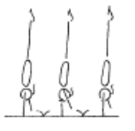 | - arms straight  - chest rounded, extended through the shoulders  - hips open  - gluteal muscles squeezed  - head neutral  - maintain good body tension and alignment
 | 8. © Handstand return to stand, fwd roll to “L” sit, reach fwd to pike stretch, candlestick, roll to stand | 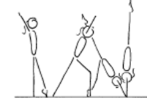 | - fingers spread  - elbows turned in  - chest in and rounded  - head neutral  - shoulders open  - hips open and gluteal muscles squeezed tight  - legs together and locked out  - toes pointed  - body must be vertical with a straight body line

MAG LEVEL 2 FLOOR (2)
Handstand Fwd Roll | 1. In front of an incline - Coach spots handstand – controlled roll fwd into candlestick position
 | 2. F3-2.2 Walk feet up the wall the near handstand, push off the wall perform a fwd roll onto a soft mat | 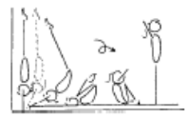 | - maintain good body tension and alignment  - encourage a straight body during the early phase of the fall  - roll in a tight tuck and stand to finish
 | 3. F3-2.1 Handstand in front on an incline, roll onto the incline – arms must be straight | 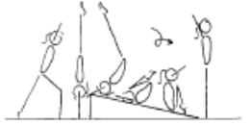 | - maintain good body tension and alignment  - place body off balance then fall  - encourage a straight body during the early phase of the fall  - roll in a tight tuck and stand to finish
 | 4. F3-2.3 Handstand fwd roll on a soft, flat surface (ie supersoft crashmat) | 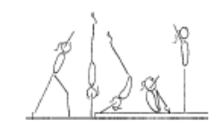 | - maintain good body tension and alignment  - place body off balance then fall  - encourage a straight body during the early phase of the fall  - roll in a tight tuck and stand to finish
 | 5. Handstand fwd roll to L-sit, reach fwd to pike stretch, candlestick, roll to stand
Cartwheel / Roundoff | 1. F1-4.5 Side cartwheel along a wall (can be done with back or stomach facing the wall) | 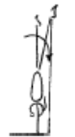 | - maintain good body tension and alignment  - pass through a plie into and out of the skill  - hands parallel, straight arms  - keep body in line bar the mat  - head neutral  - small straddle  - keep arms by ears all through the skill
 | 2. F2-3.4 Have the gymnast perform 2-3 fast side cartwheels in a row, passing through a plie action between cartwheels | 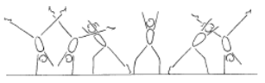 | - keep shoulders and hips square  - pass through plie between cartwheels  - head neutral  - generate speed  - move in a straight line  - arms by ears  - maintain good body tension and alignment
 | 3. © Cartwheel to side | 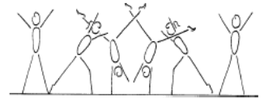 | - start in forward lunge  - good rhythm - foot, hand, hand, foot, foot  - body remains in the vertical plain  - body remains in a straight position - no arch, no pike  - head remains neutral  - small straddle during the hand support phase  - finish in a side position
 | 4. F3-3.1 Have the gymnast stand in a small straddle with their arms overhead (simulating the side handstand position), they perform a ¼ turn to the left return to the middle and ¼ turn to the right | 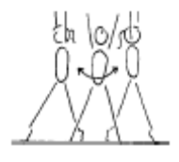 | - keep hips open and tight  - chest in  - emphasise square hips and shoulders  - emphasise the 1/4 turn action
 | 5. F3-3.2 With coach assistance perform the entry to a vertical side handstand with a small straddle, have the gymnast ¼ turn to the left and return to the middle then ¼ turn to the right and return to the middle | 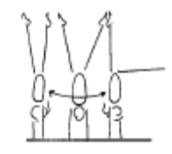 | - this drill emphasises the 1/4 turn action and square position needed to perform the cartwheel snap up and the round off  - keep hips open and tight  - chest in  - emphasise square hips and shoulders  - emphasise the 1/4 turn action  - encourage the gymnast to look towards where their foot would land
 | 6. Lying on back on floor – start in star position and turn hips/shoulders ¼ turn each way to learn ¼ turn
 | 7. Learn hand position for ¼ turn cartwheel
 | 8. Against a wall – cartwheel to stop in handstand – coach assists gymnast to ¼ turn and step down
 | 9. ® ©Cartwheel with a ¼ turn in to stand | 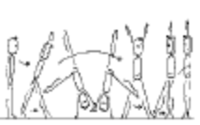
  - Raise arms forward to vertical position. Kick leg forward to cartwheel. From straddle stand sideways, step backward with ¼ inward turn bringing feet together to stand

MAG LEVEL 2 FLOOR (3)
Cartwheel / Roundoff con’t | 10. Cartwheel step-down from a raised surface (bench or box)
 | 11. F3-3.3 Perform the cartwheel down an incline – emphasizing the ¼ turn | 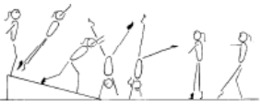 | - keep hips open and tight chest in  - emphasise square hips and shoulders throughout  - emphasise the 1/4 turn action
 | 12. Cartwheel step in (snap) | 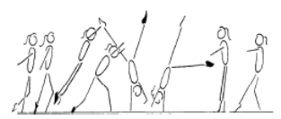 | - start with square hips and shoulders in the direction of travel  - lunge into the cartwheel maintaining square posture  - kick to a vertical side handstand with a small straddle  - first hand is placed same as a side cartwheel and becomes the support and rotational hand  - second hand is turned a 1/4 turn and placed pointing towards the first hand and becomes the repulsion hand  - head neutral  - body rotates 1/4 turn so that shoulders and hips are now square and facing the direction of travel  - head is neutral and eyes can see where the foot is about to land  - keep arms straight and chest in  - once the body is vertical over the second hand the chest lifts and the feet come down causing a ‘see-saw’ illusion  - the shoulders must not go past the vertical line  - finish in a stand with arms forward low horizontal  - chest in, hips open
 | 13. Courbettes from BB | 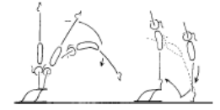 | - maintain body tension and alignment  - head neutral  - hands slightly turned in  - shoulders remain over the initial support position  - bounce from the floor
 | 14 F4-2.5 Perform a roundoff from a rebound surface to a lower landing surface – onto feet | 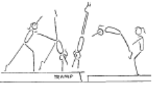 | - ensure the body remains within the vertical plain, no pike or arch action  - maintain good body tension and alignment  - repulsion from hands occurs during the vertical phase when the body is travelling upwards with the heel drive  - land in a dish shape with arms forward low horizontal
Backward Roll (for back salto) | 1. ®© Bwd Roll | 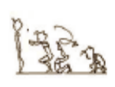
  - Tucked backward roll to squat position.
 | 2. Bwd roll (tuck) to squat – straight arms |  | - Legs together  - Smooth rolling action
 | 3. Bwd roll to candlestick
 | 4. F2-4.4 Back extension roll down an incline with straight arms to a front support (then on the floor). The gymnast can start on 1 leg, a perfect rounded dish shape can then be maintained throughout the body, during the roll | 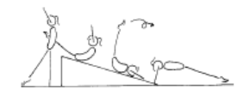 | - have arms turned in so little fingers contact the floor first  - keep arms locked  - legs together  - land in front support with toes under  - maintain body tension and alignment  - head neutral
FWO, BWO & Tic Toc | 1. F2-5.4 Bridge with feet raised on a box, hold for 2 secs – kick over to stand | 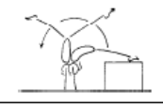 | - use shoulder and hip flexibility  - straight legs in the bridge  - straight arms throughout the skill  - pass through a vertical handstand position with legs in stride
 | 2. F2-5.5 From kneel, perform a bridge onto a high raised surface and return to stand
 | 3. Standing close to wall – gymnast walks down wall to bridge
 | 4. ®© Bridge | 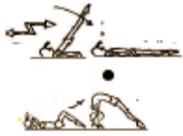
  - Lower to backward lying position and circle arms backward to extended position. Place hands under shoulders and push to bridge position (hold 2 secs).
 | 5. F2-5.5 From stand, perform a bridge onto a lower raised surface and return to stand | 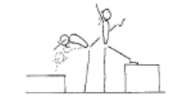 | - arms by ears with eyes looking at hands  - use shoulder and hip flexibility  - straight arms throughout the skill
 | 6. F2-5.6 Gymnast performs a handstand and the coach supports the gymnast into an arch shape
 | 7. Spotted limber down to bridge & back up again to stand
Hurdle | 1. F4-2.2 Stand in dish shape – leaning against a partner | 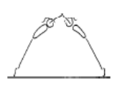 | - maintain good body tension and alignment  - chest in, hips under  - arms by ears  - head neutral
Handspring | 1. Handstand onto a box – fast snap of legs

MAG LEVEL 2 HORIZONTAL BAR (1)
Front Support /Casts | 1. B2-3.3 Straddle cast to rest feet on a shape – return to the bar | 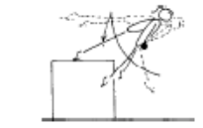 | - arms must stay straight with shoulders over the bar  - head neutral  - fast backward body snap action  - strong front support position when feet land on the shape
 | 2. Casts caught by coach to correct shape | 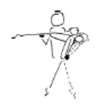 | - arms must stay straight with shoulders over the bar  - head neutral  - fast backward body snap action  - coach assists by momentarily supporting the gymnast in the ascent peak phase to check body tension, then allows the gymnast to continue  - straight body shape at the ascent peak phase
 | 3. 5 x casts in a row
 | 4. © 2 x Casts to 45’ below horizontal | 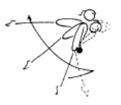 | - straight arms throughout the cast  - bring feet in front of the bar to initiate cast  - tip shoulders forward slightly  - cast feet backward and upward with a strong backward body snap  - straight body position at the ascent peak of the cast  - head neutral  - maintain good body tension and alignment during all phases of the cast  - return to the bar
Pullover | 1. Pull to Chin up position – 5 x leg lifts
 | 2. Show inverted hang position – push/roll body over to front support
 | 3. ® © Pullover (coach assisted) | 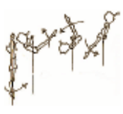
  - Chin up and hip pull over to front support (may be coach assisted)
 | 4. Pullover to feet on box
Back Hip circle | 1. B3-1.3 From front support, perform a ‘tip upside down’ maintaining a straight body, then finish the 2nd half of the circle still maintaining a straight body with coach assistance | 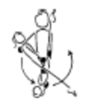 | - head neutral  - maintain good body tension and alignment  - fast wrist action on completion of circle
 | 2. B3-1.3 From front support perform a fast ‘tip around’ with coach assistance |  | - head neutral  - maintain good body tension and alignment  - fast wrist action on completion of circle
 | 3. B3-1.1 Cast to invert, run up the hill (using a wedge shape tied to the bar) | 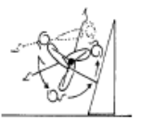 | - minimum cast of 45’  - drop shoulders back fast  - bring hips and feet under the bar fast  - place feet on the shape and run up the hill and pullover  - fast wrist action on completion of circle  - complete circle by finishing in strong front support position
 | 4. ®© Cast, backward hip circle | 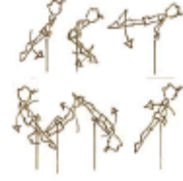
  - Cast back hip circle (coach must stand on a box to spot if required)

MAG LEVEL 2 HORIZONTAL BAR (2)
Long Swings & Long Swing Pullover | 1. B2-4.2 From a straight hang on the bar the gymnast performs tap swings, the coach can spot the gymnast by placing their hands on the gymnasts stomach and back initiating and supporting the tap swing | 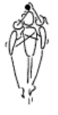 |  |  | - the coach can remind the gymnast of the Key Points  - a strong rhythm must be visible  - gymnast must feel a good rhythm  - maintain good body tension and alignment
 | 2. B3-4.1 From standing on the low bar, start in dish position, swing through into an arch swing fwd and return through arch and stand on the bar in a dish shape | 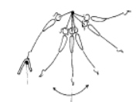 |  |  | - ensure a good understanding of the key shapes  - evident power generated from strong tap forward and backward  - maintain good body tension and alignment
 | 3. B4-5.1 Chin up pullovers x 5
 | 4. ®© Underswing, 2 x basic swings, dismount on back of 3rd swing | 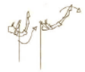 | 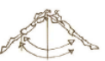 | 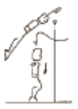
  - Underswing to swing backwards
  - Swing forwards & backwards x 2
  - And release to dismount on third back swing. Swing to 45’
Kips | 1. B3-6.2 Box kip, start with box under the bar, gymnast moves the box fwd as they improve | 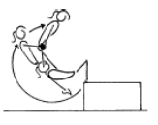 |  |  | - arms straight throughout the skill  - fast jump  - fast wrist action  - closed front support position on completion
 | 2. B4-3.1 – Simulate kip action with broom stick, lying on back | 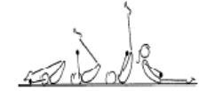 |  |  | - emphasise full stretch before bringing feet to the bar  - straight arms throughout  - shoulders forward over bar  - feet finish in front of bar - closed pike shape  - head neutral
 | 3. Using bungee cord tied to ladder – begin holding bungee high above head with straight arms – pull bungee cord quickly towards thighs
 | 4. B4-3.4 – From front support – coach spots drop to hanging pike position
 | 5. B4-3.4 From hanging pike position – coach spots gymnast to ‘shoot’ toes to the roof – repeat x 5
 | 6. Teddy throws – gliding with teddy between feet – snap feet to bar trying to throw the teddy over the bar
 | 7. Straddle leg lifts – hanging on a high bar. Show star, rotate hips under through straddle position and up to touch bar x 5

MAG LEVEL 2 VAULT (1)
Bounce /Spring | 1. Ankle raises x 20 with both feet then 15 on each leg
 | 2. V1-5 Springing Circuit – variety of 8 objects | 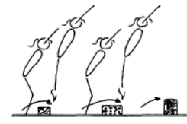 | - maintain good body tension and alignment  - continuous bouncing, no pauses or stops  - easy clearance of the objects
 | 3. V1-4.3 Cross arm skipping x 10
Running | 1. V3-3.2 Running with high knees | 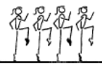 | - head neutral  - extend through ankles and toes  - lift knees to hip height with a fast powerful action  - arms in line with body
 | 2. Running “kicking bottom” with feet (pointed toes)
 | 3. Resistance Running – with bungee cord | 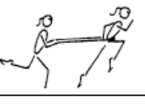 | - lift knees  - lean forward  - head neutral
 | 4. V3-3.1 Bounders – the ideal position/action can also be practice on the floor or hanging from something | 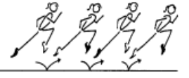 | - head neutral  - lift the knee high at the front  - lift the leg high at the back with minimal bend  - arms in line with body
Hurdles | 1. Step hurdle punch to 8’ mat – correct arms
 | 2. V1-3.1 Perform hurdle from the edge of a 30cm box – to a board, up to a 30 or 60cm box – using correct arms | 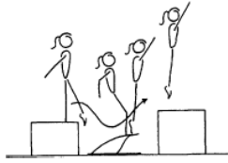 | - underarm action  - fast explosive bounce  - arms stop at 45’  - maintain good body tension and alignment
Straight Jump Vault | 1. Short run, hurdle with arm circle, 2 feet take off, straight jump from spring board to 60cm crashmat or box
Catsprings -Handspring Vault | 1. V2-2.4 Seal walks | 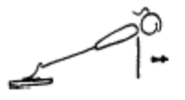 | - rounded back  - hips under  - arms straight  - head neutral
 | 2. Clap pushups on floor
 | 3. Jump to 45’ handstand over object
 | 4. ®© Squat jump onto vault table with immediate stretched jump to land | 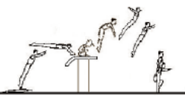
  - Squat jump onto vault table and immediate stretch jump to land
 | 5. Fast kicks to handstand with legs “snapping” onto padded wall
 | 6. Straddle on to 3’ box, jump off to SLP
 | 7. V2-2.5 Cat Springs on a rebound surface (double mini) | 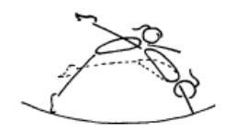 | - dynamic action  - open hips  - good heel lift (backward body snap)  - maintain good body tension and alignment

MAG LEVEL 2 POMMEL (1)
Front Support & Straddle Swings | ®© Straddle Swing in front support x 3 | 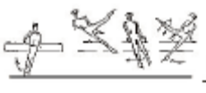
  - Jump to front support. Swing to the left and to the right with legs straddled.
Stride Supports & Swings | ®© Stride Swing Left Leg Fwd | 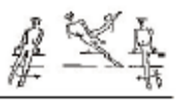
  - Swing both legs to the left, swing left leg in over left handle.
Dismount | ®© R Leg over with 90’ dismount | 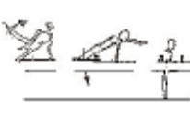
  - Swing to the right in stride support.
  - Swing right leg in over the right handle and dismount with 90º turn to the left.

MAG LEVEL 2 RINGS (1)
Hangs | ®© From Hang – pull to chin up position | 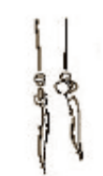
  - From hang pull upward till head is at ring height (chin up).
 | ®© Tucked lift to inverted hang 2s | 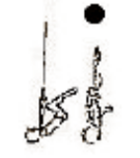
  - Lift through tucked position to stretched inverted hang (2 secs).
 | ®© Piked Inverted Hang | 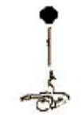
  - Lower legs to piked inverted hang (2 secs).
 | ®© Lower to L Hang | 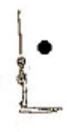
  - Lower to a straight arm hang in L position (2 secs).
Swings | ®© Swing bwd, fwd, bwd, fwd | 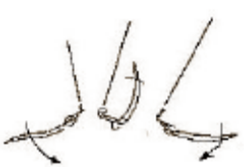
  - Swing legs backward and forward,
Dismounts | ®© Swing bwd & release to dismount | 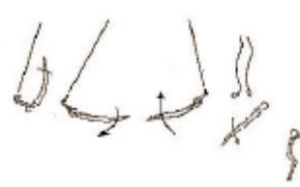
  - Swing backward, Dismount on 3rd backward swing

MAG LEVEL 2 P BARS (1)
Supports | ®© Jump to support (with or without assistance) – lift to L sit | 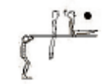
  - From stand at the end of the bars jump to momentary support with straight body, then lift legs to L-sit (hold 2 secs).
 | ®© Straddle Sit | 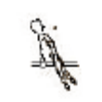
  - Straddle legs to momentary straddle support on the bars, hands behind the hips.
Swings | ®© Support swing bwd & fwd x 2 | 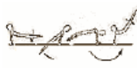 | 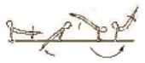
  - Raise legs off the bars and swing backward and forward. Feet at least to bar height at each end.
  - Swing backward to at least horizontal and forward, feet at least to the height of the bar.
Dismounts | ®© Swing bwd to dismount at end of bars | 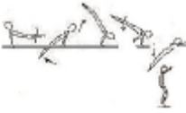
  - Swing backwards to 45º above horizontal and dismount to stand at the end of the bars.

